Decimal is base 10

Binary is base 2

Octal is groups of binary

Hexadecimal groups of binary

Byte= 8 bits

All 256 possible can be represented by 2 hex

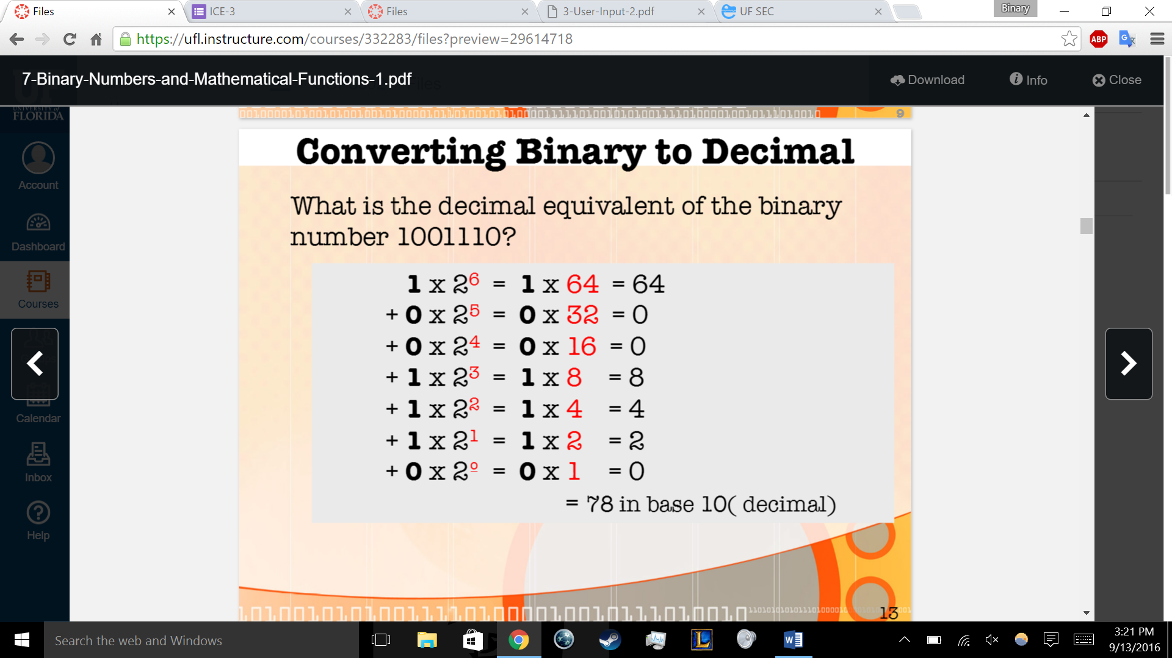

0+0=0

1+0=1

0+1=1

1+1=10

1+1+1=11

Overflow = an extra digit that cannot be represented by computer

Hex

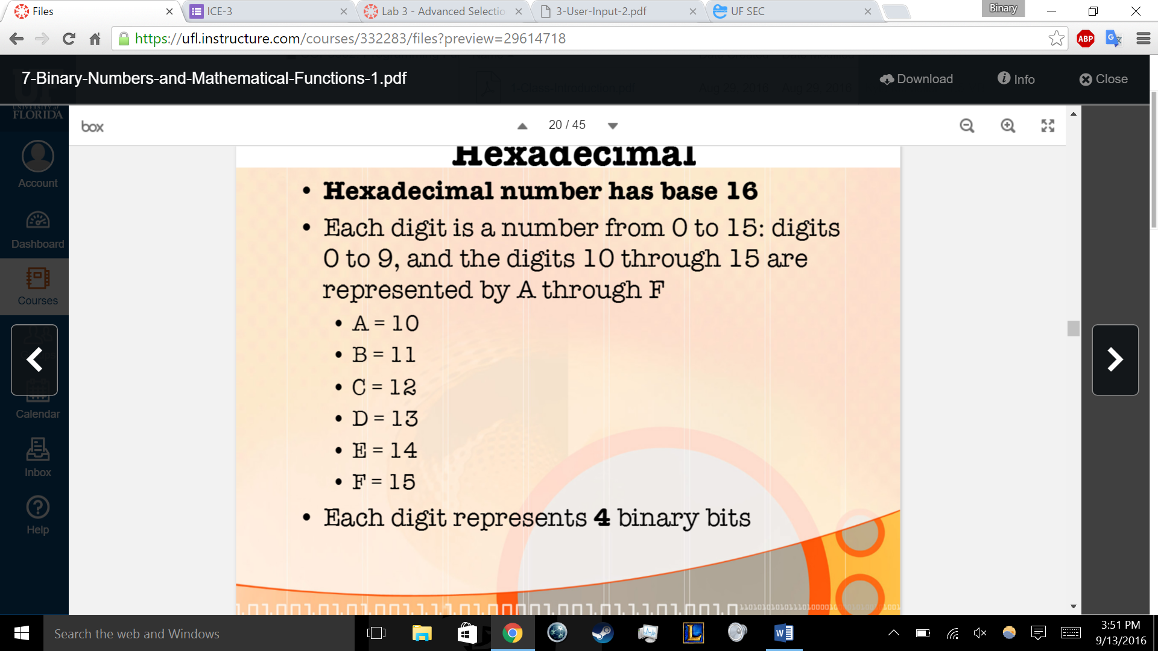

UNICODE IS ON TEST

Int I = ‘a’; // looks up the decmal code that a represents

